Identity, Sphere of Influence, and Authority
Done in small groups of 6-7
Goal: Identify leverage and connecting points within our personal and collective network to make pockets of change for youth, especially within your roles in education.
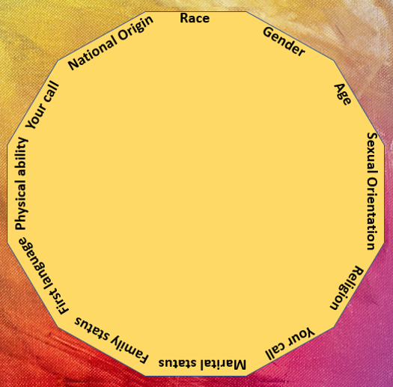
STEP 1: Refer back to the list of self-identities from the “Identity Wheel”. Place a star next to the identities where you have perceived power, whether it be through social capital, your profession, and/or networks you are associated with.

It’s important to name these networks. Keep these in mind for Step 2.

STEP 2: In your small groups, please discuss the following questions and record your answers. You will use these answers in STEP 3.

STEP 2 Discussion Questions
- Where do you currently experience or witness inequity, barriers, or frustration related to inequity with current institutional systems that are in place?
- Who is being impacted the most by these barriers?
- How can you use the power and sphere of influence you starred in #1 to begin to address the inequities?

STEP 3
Thinking about your responses to #3, choose 1 of the strategies and work together to describe how you would approach it within your center/program. Refer to the diagram and description of the strategies below.

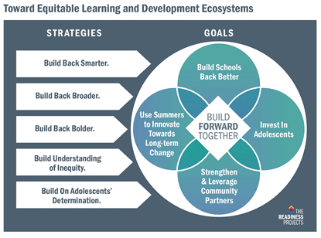
Source: The Readiness Projects
The Readiness Projects

Strategies defined:
- Build Back Smarter: Acknowledge learners’ losses while affirming learning ability. Optimize learning environments while prioritizing reconnection.

- Build Back Broader: Support complementary learning delivery systems and modalities. Invest in program-level staff and city-level coordinating structures.

- Build Back Bolder: Focus on how, why, and with whom learning happens. Respect and diversify learner’s experiences, contexts, and adults’ expertise and power.

- Build Understanding of Inequity: Equity is the goal, but inequity is the reality. Acknowledging skepticism, take time to get baseline data right in order to truly cover all bases.

- Build on Adolescents’ Determination: Embrace adolescent risk taking and leverage the brain science. Create and support alternative success pathways for all adolescents to be competent, connected, confident contributors.

STEP 3
Thinking about your responses to #3, choose 1 of the strategies and work together to describe how you would approach it within your center/program. Refer to the diagram and description of the strategies below.

